**ASSIGNMENT-1**

**MODULE 7**

**MARIA DB**

**DONE BY**

**RANJITH KUMAR**

**Tasks:**

**1. Create a MariaDB Engine based RDS Database.**

**2. Connect to the DB using the following ways:**

**a. SQL Client for Windows**

**b. Linux based EC2 Instance**

STEP 1 : Open RDS from aws services

STEP 2 : Databases > Create database

STEP 3 : Select mariadb from engine type

STEP 4 : Select templates , credentials , instances class , network , storage , and needed details to create a database

STEP 5 : Mariadb database is created

STEP 6 : Create an EC2 instances with linux based(Ubuntu)

STEP 7 : Select the security group of the database create a rule allowing mysql(3306)

STEP 8 : Connect to the instance and update it(**sudo apt-get update -y**)

STEP 9 : Install mysql server and client using the command :- **sudo apt mysql-server mysql-client**

STEP 10 : Use the endpoint from RDS to connect.Command:- **sudo mysql -h(endpoint) -u(username) -p(password)**

STEP 11 : Connected to mysql in linux based instance

STEP 12 : Now open MYSQL workbench installed in our system

STEP 13 : Use endpoint as host name and test connection

STEP 14 : Use password to connect

STEP 15 : Select the new connection to open

STEP 16 : Connected the db using the windows mysql

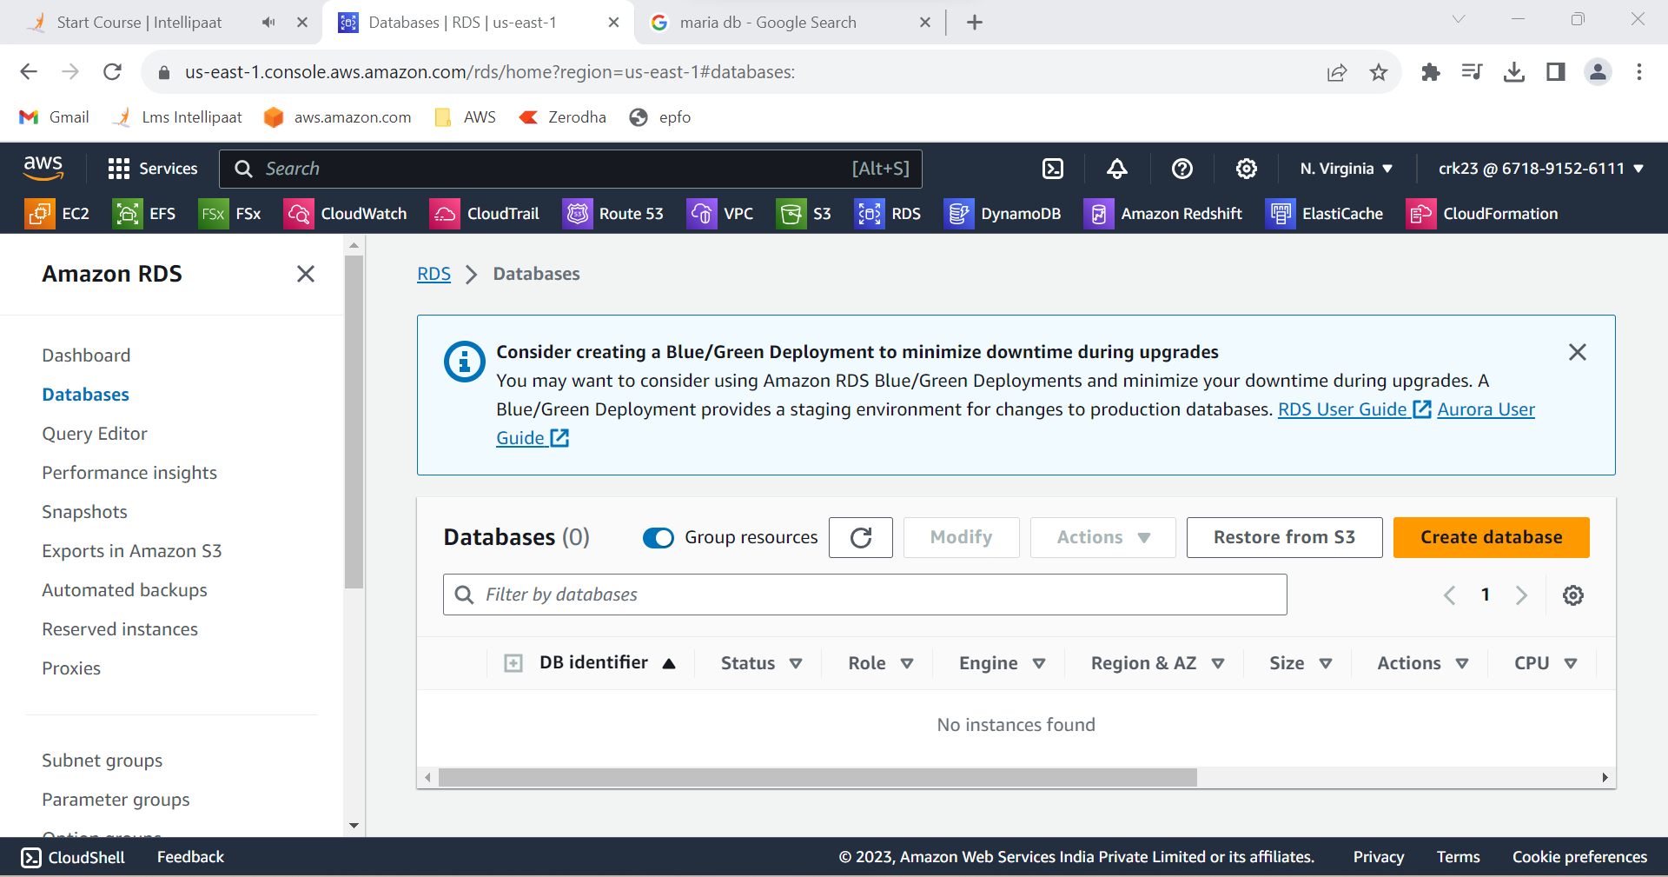

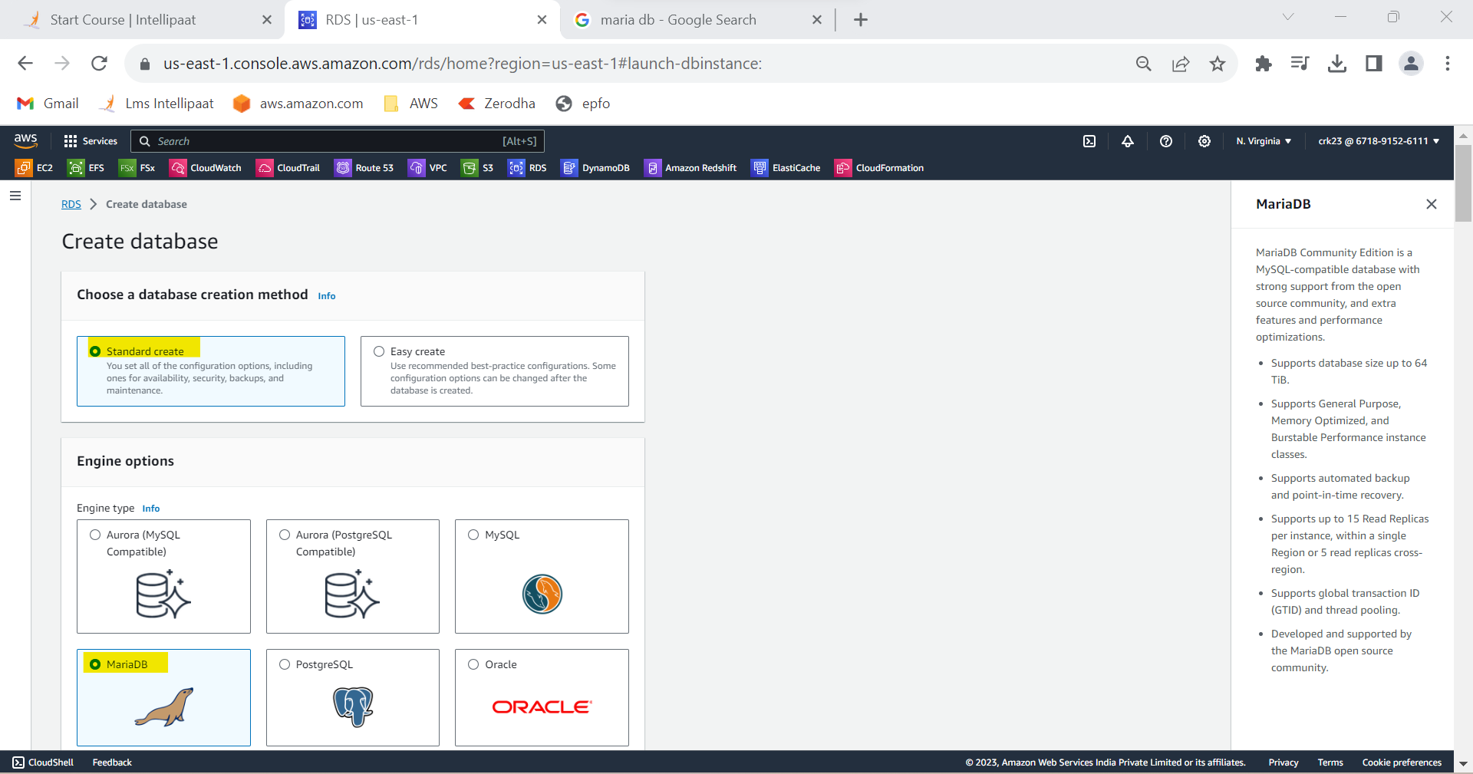

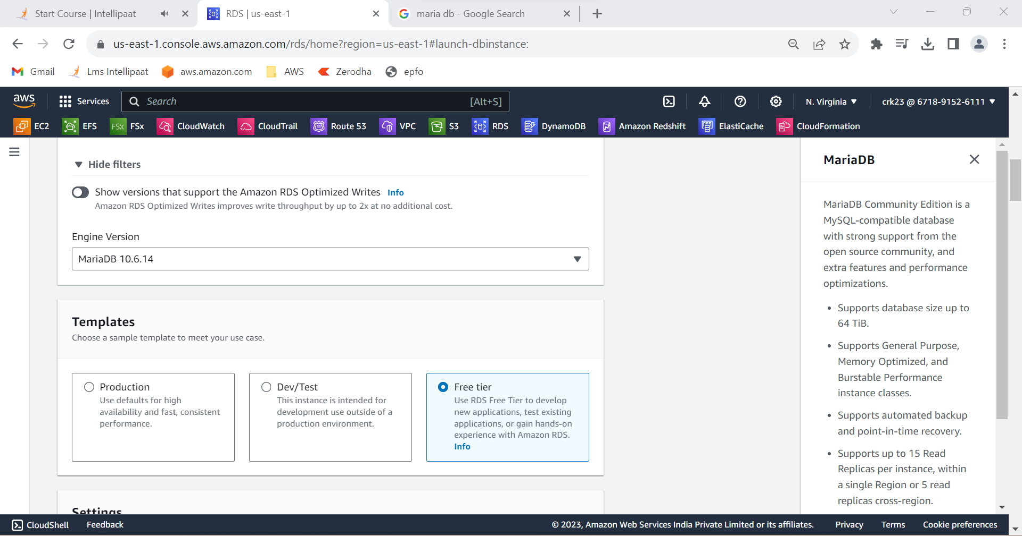

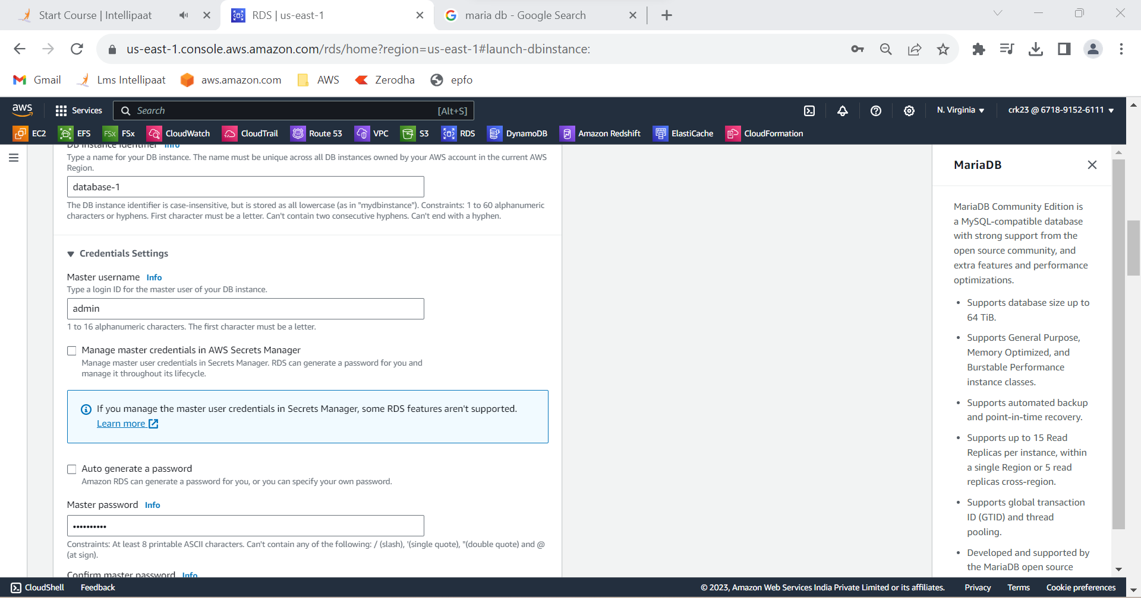

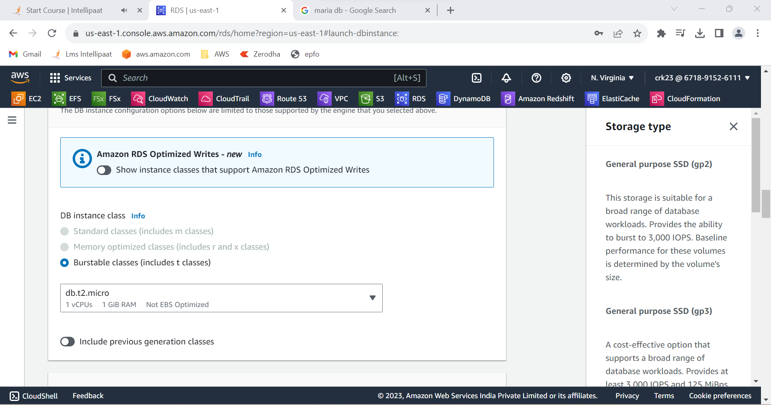

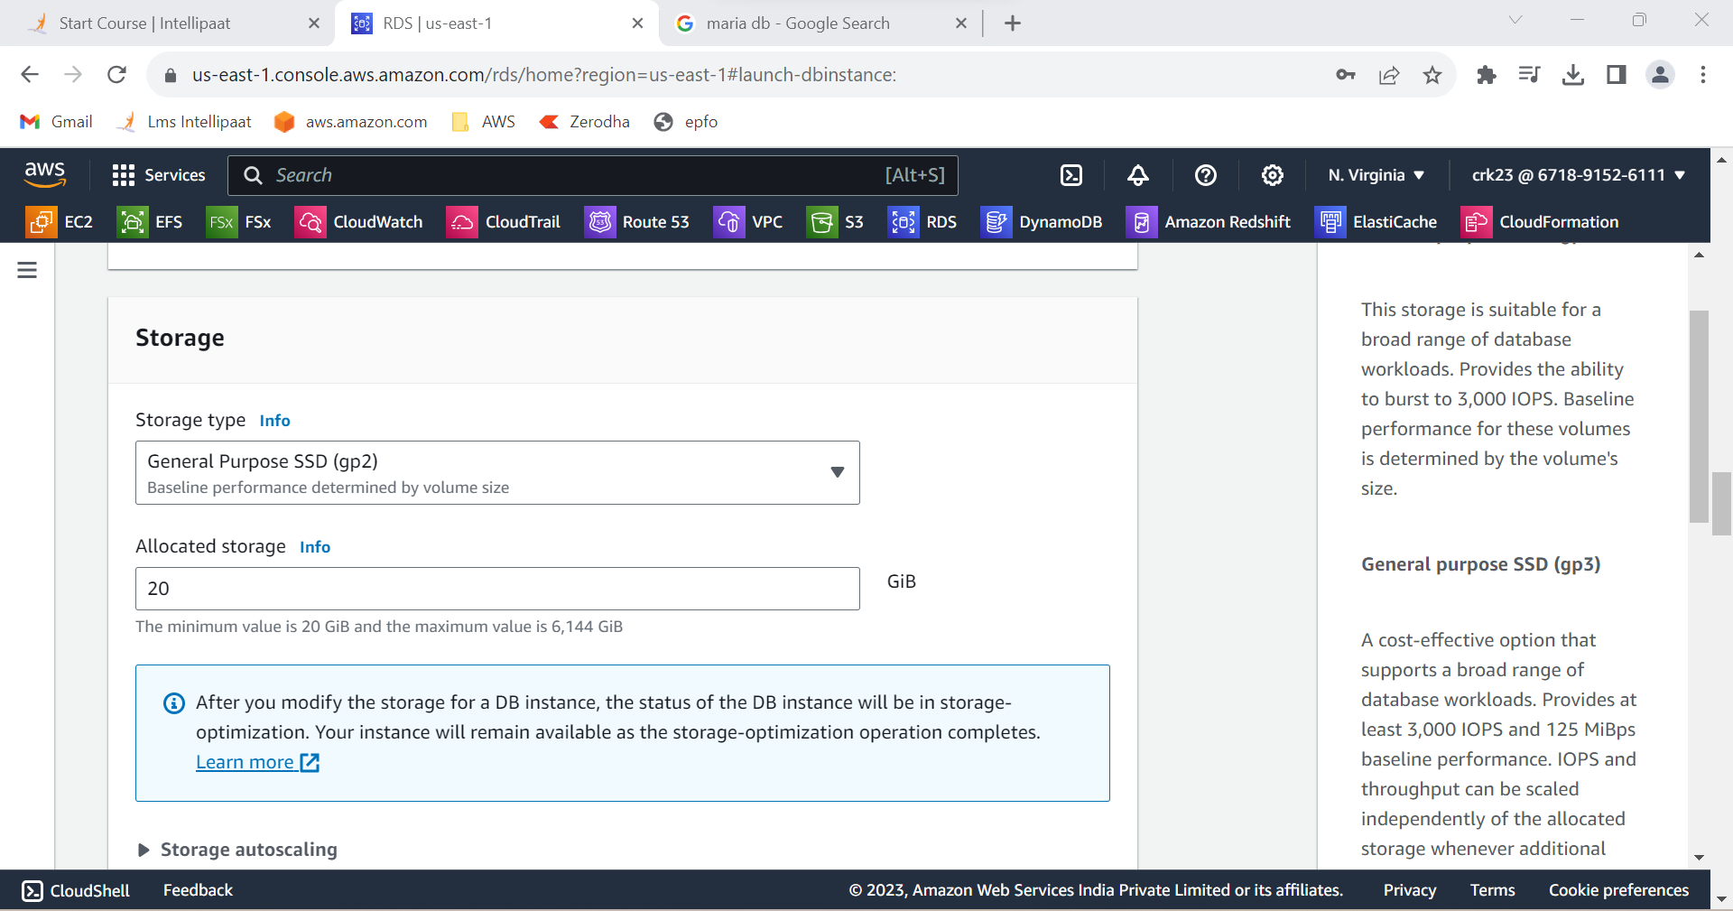

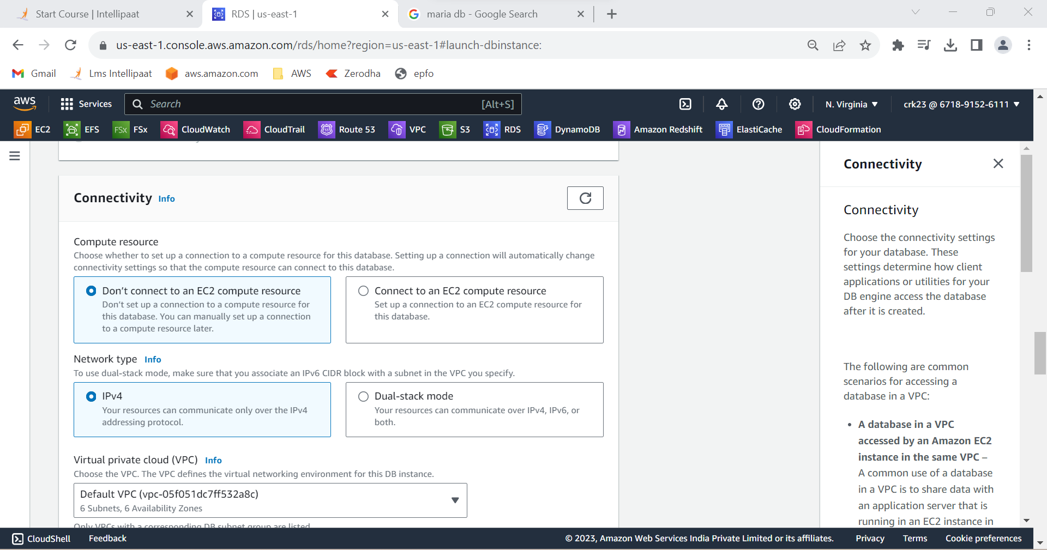

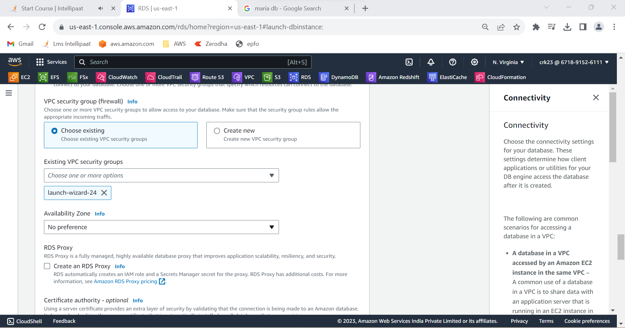

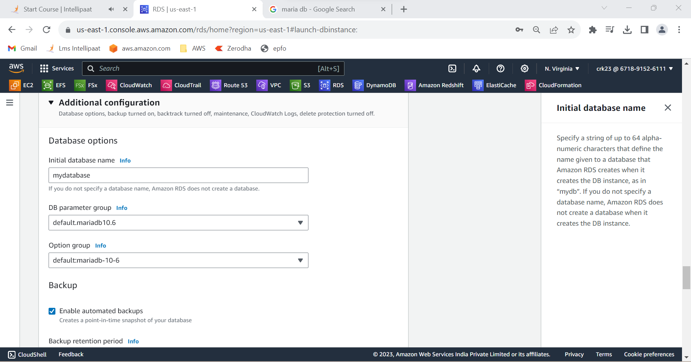

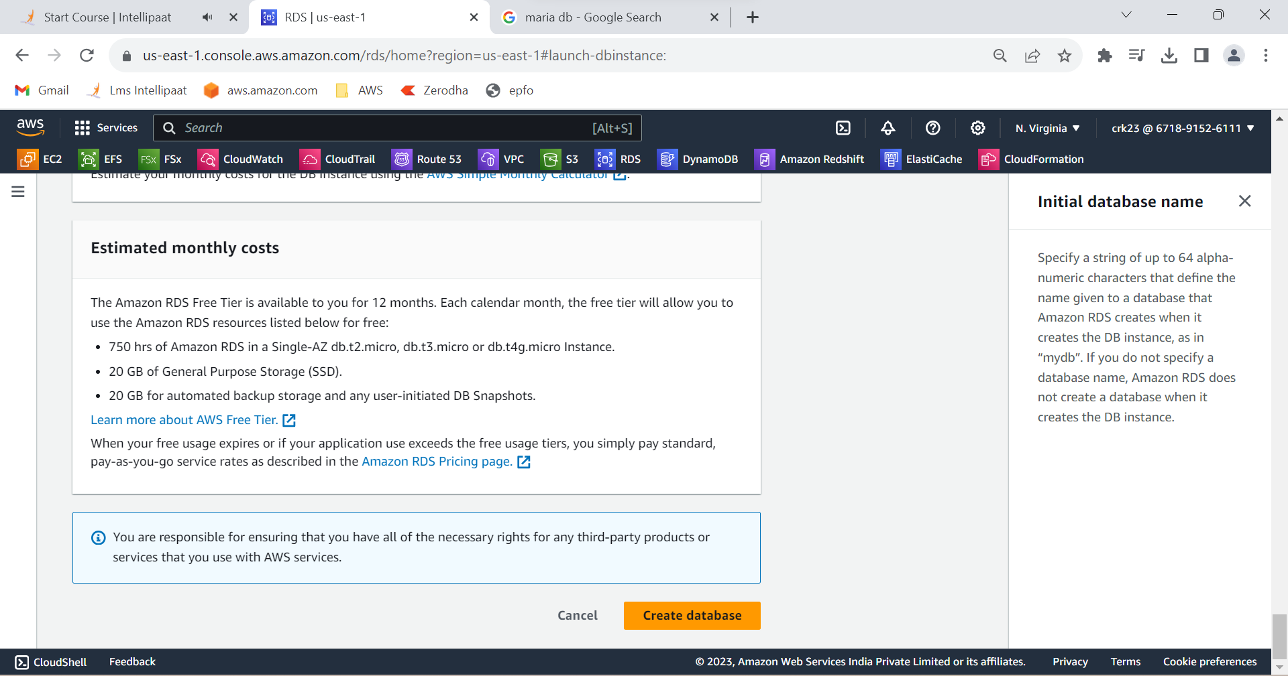

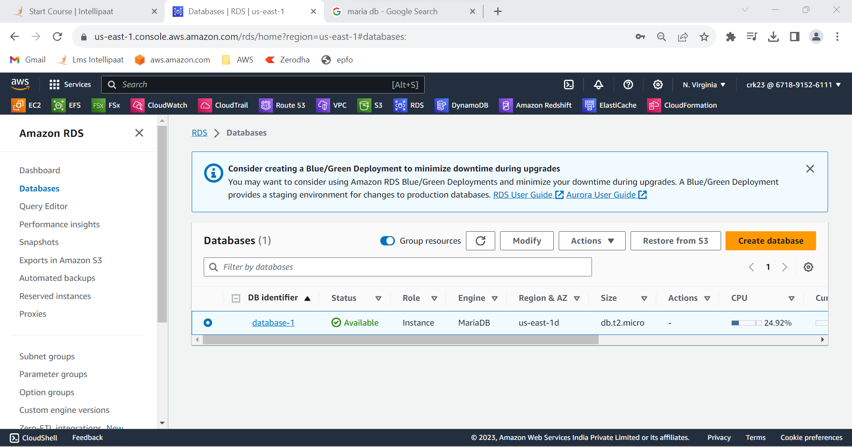

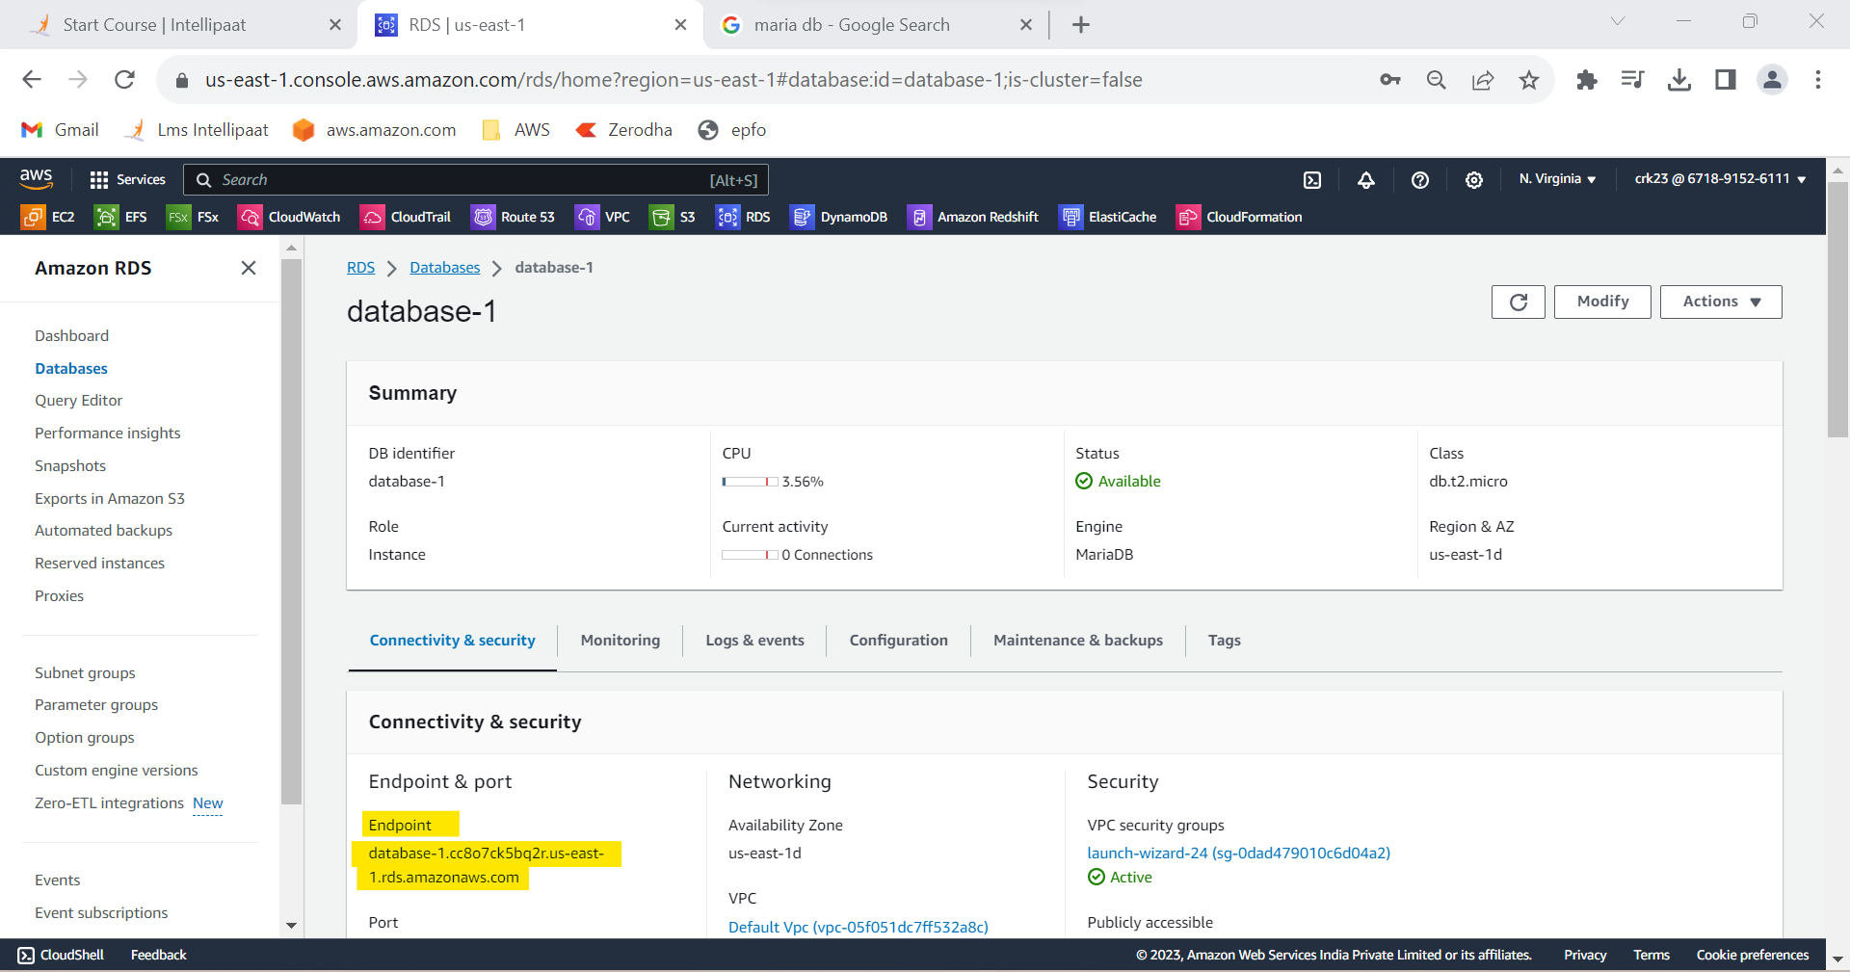

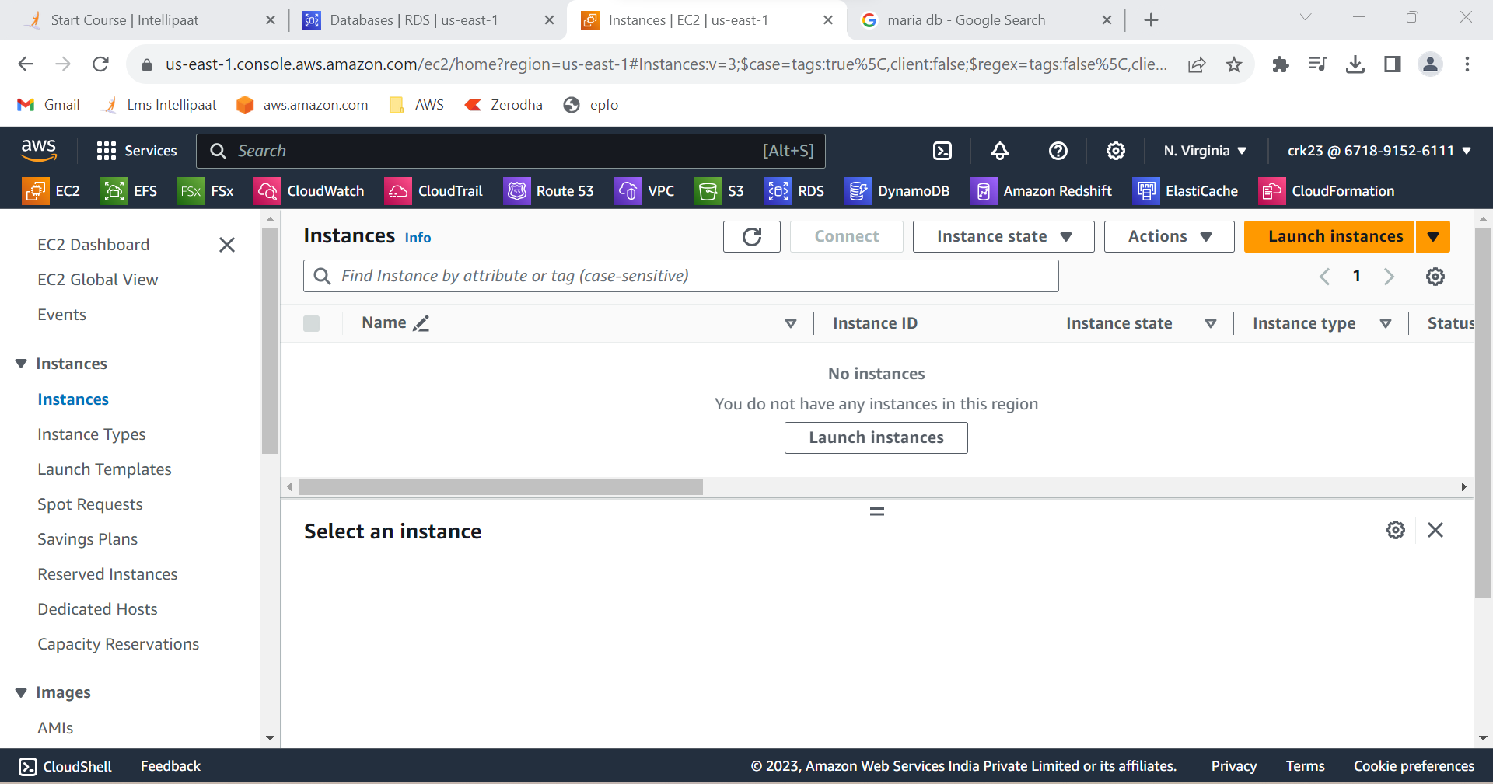

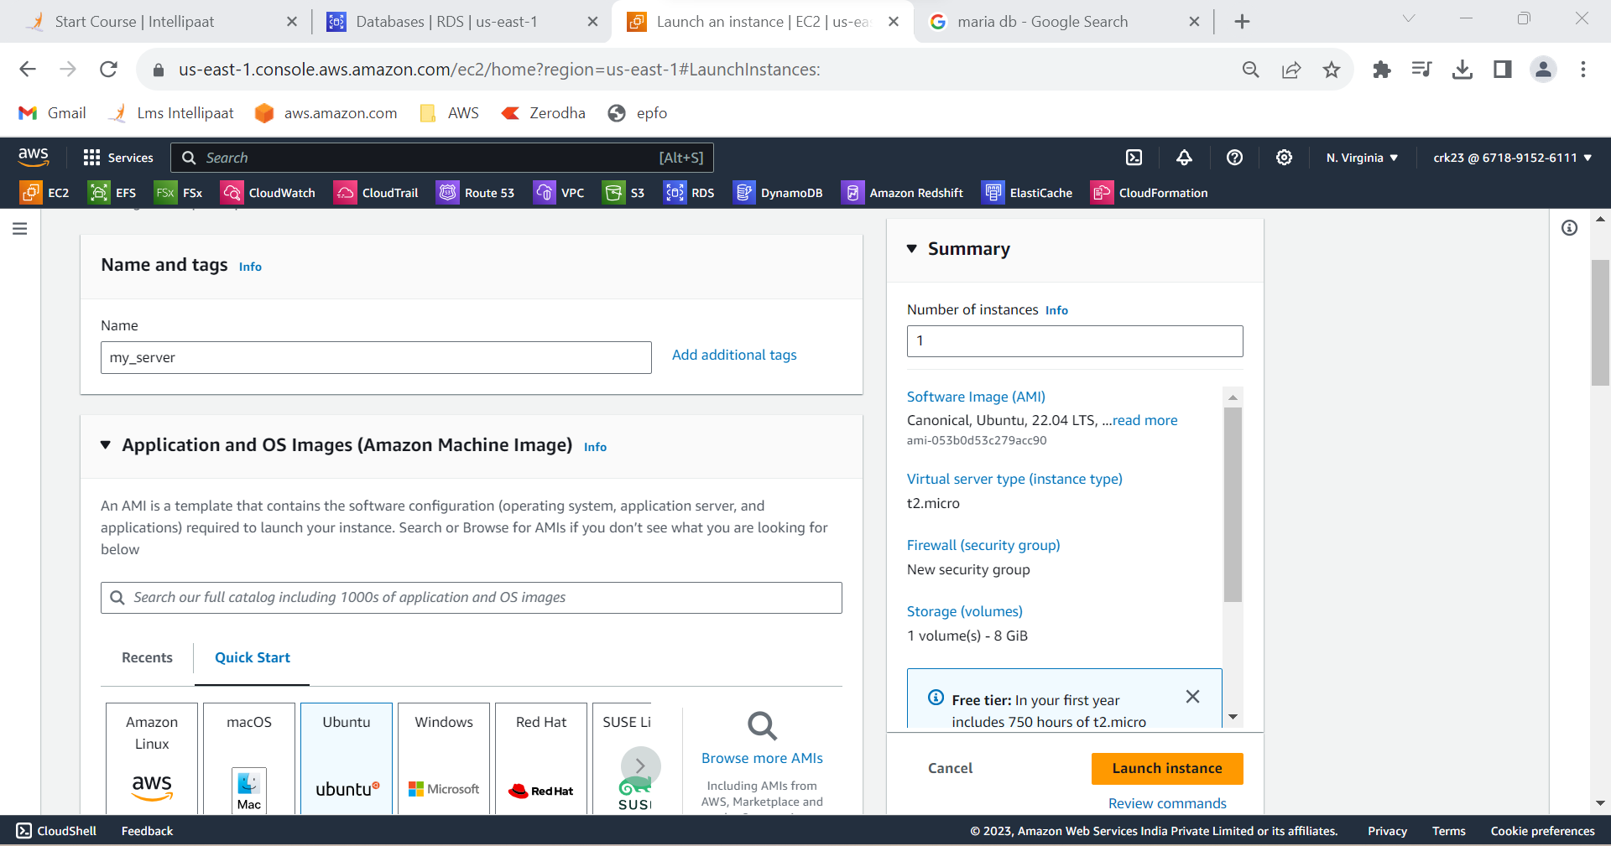

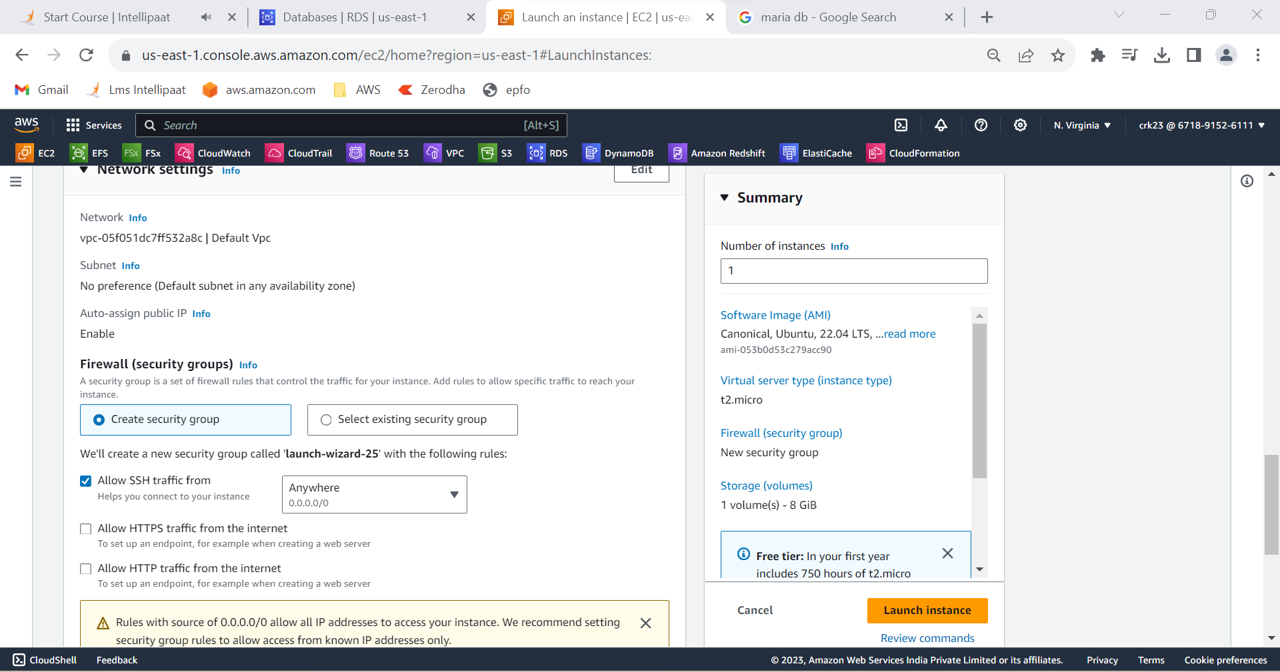

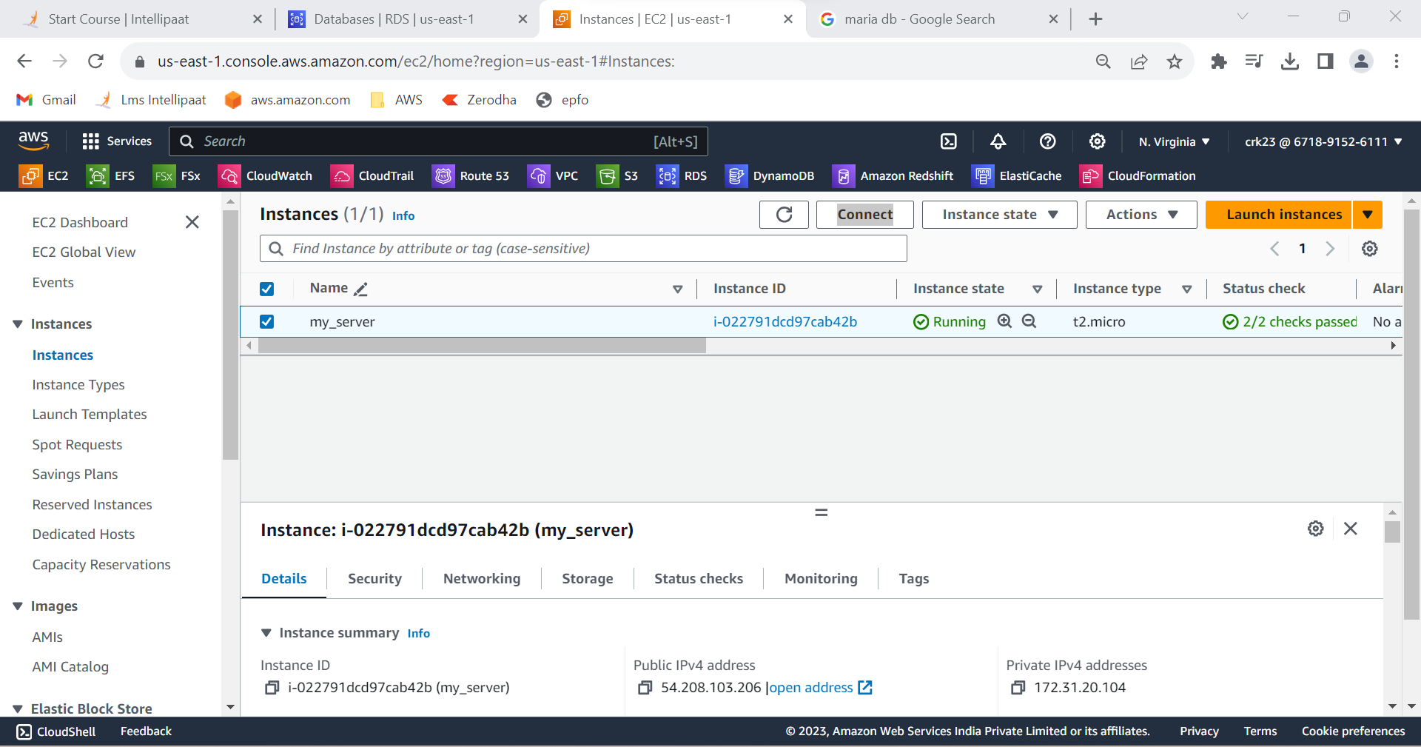

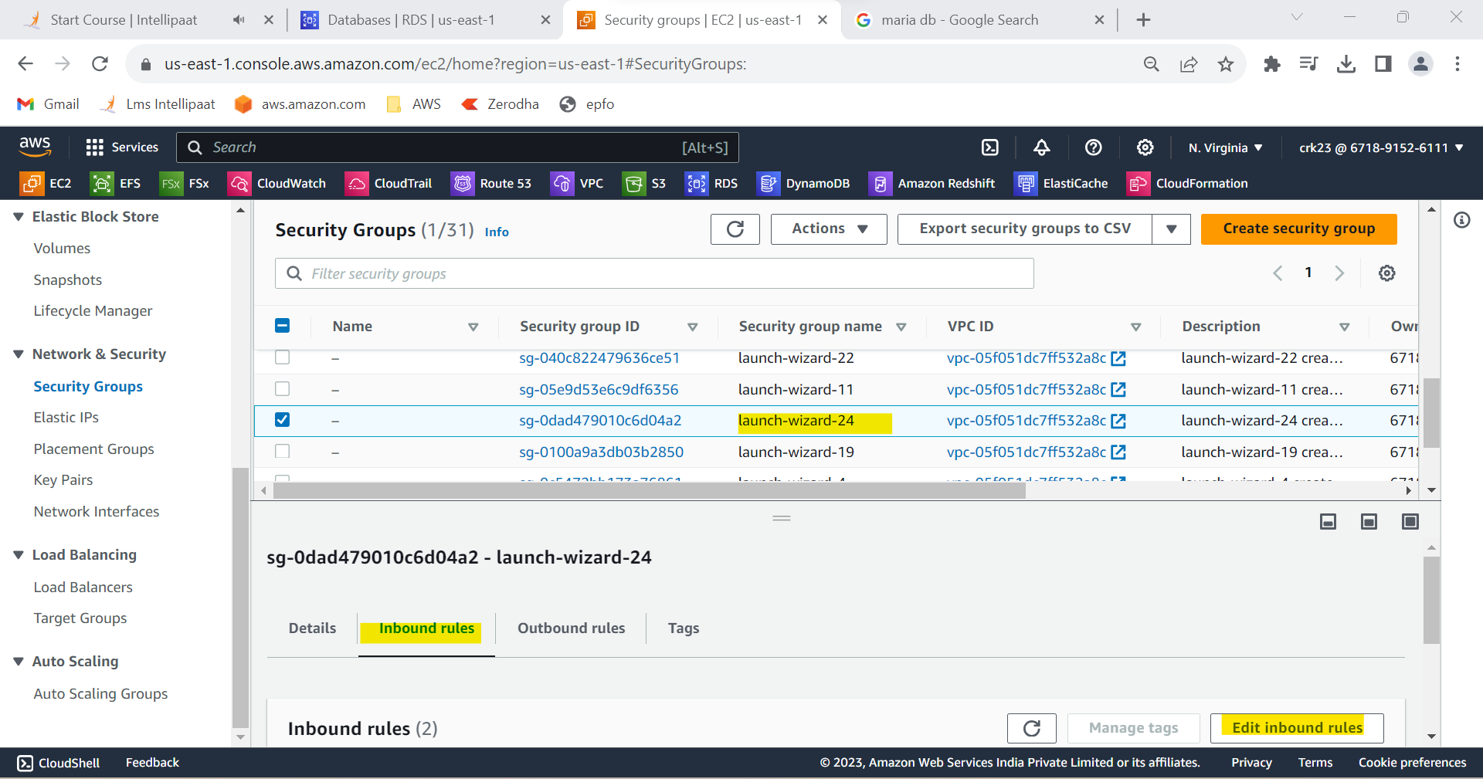

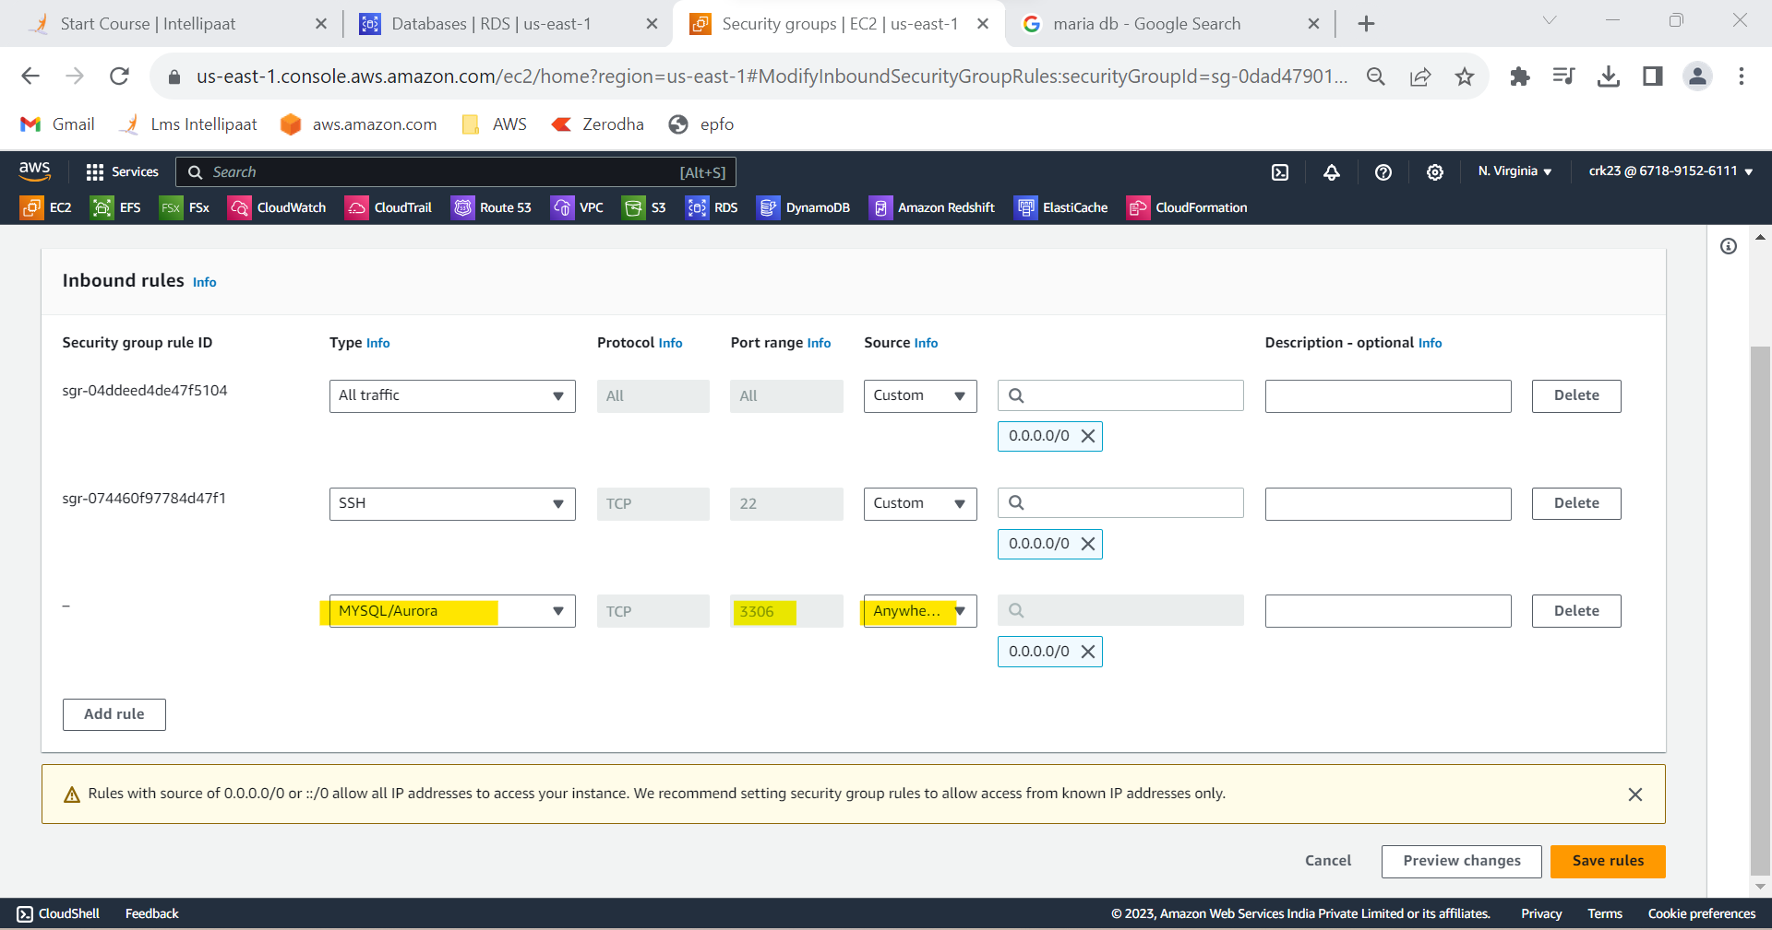

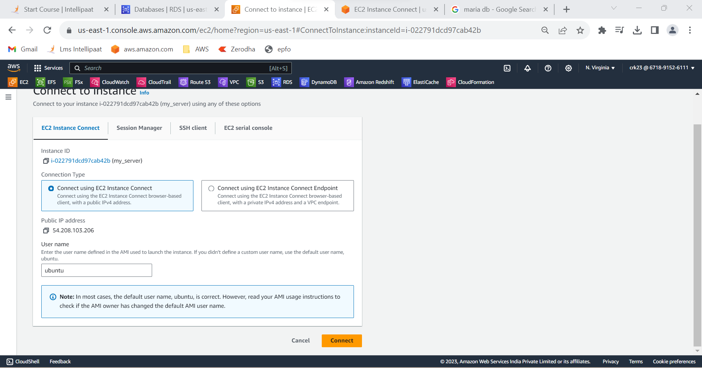

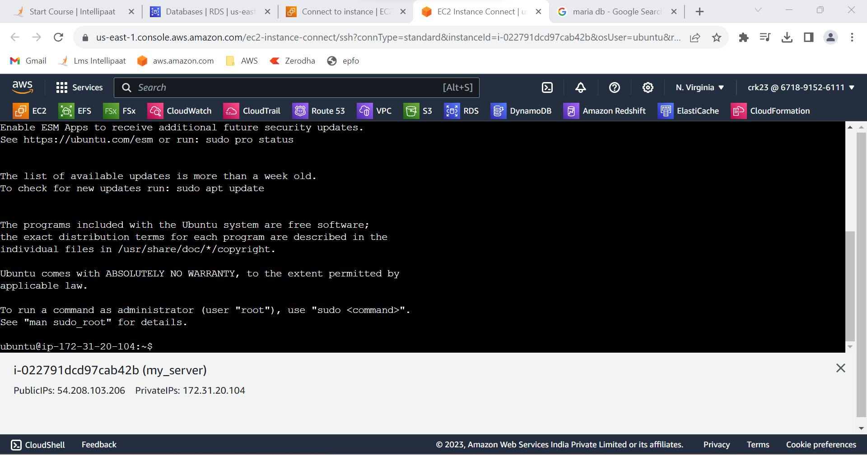

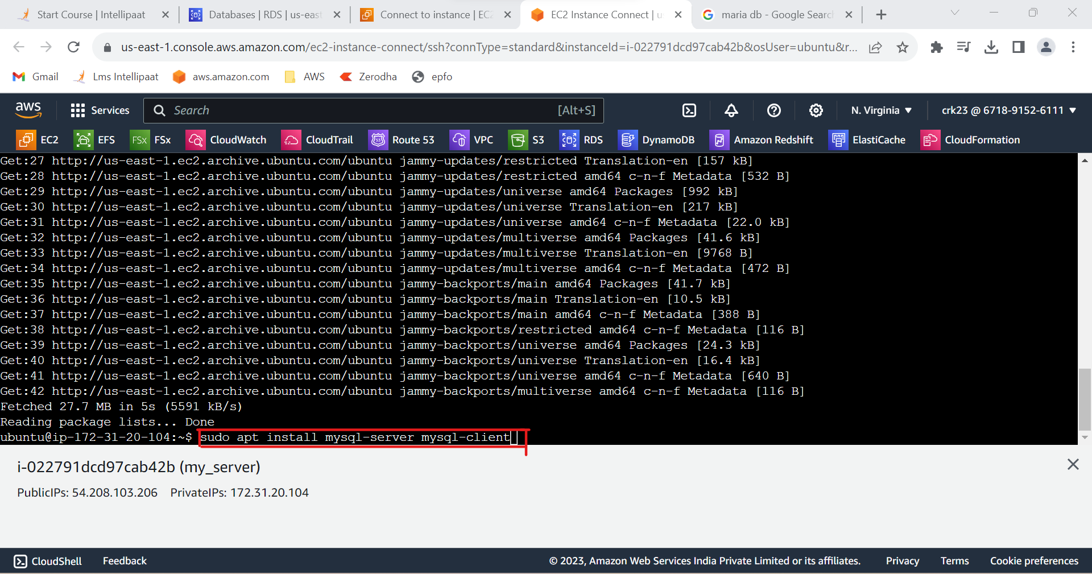



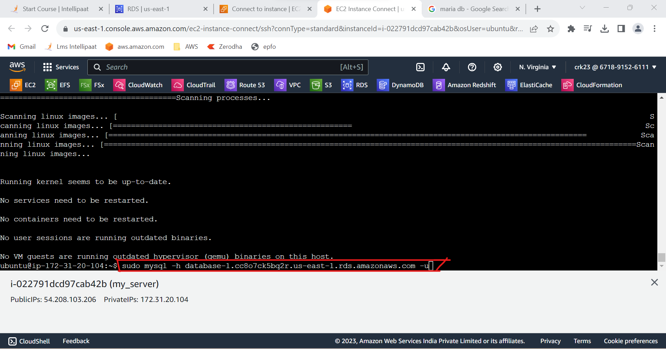

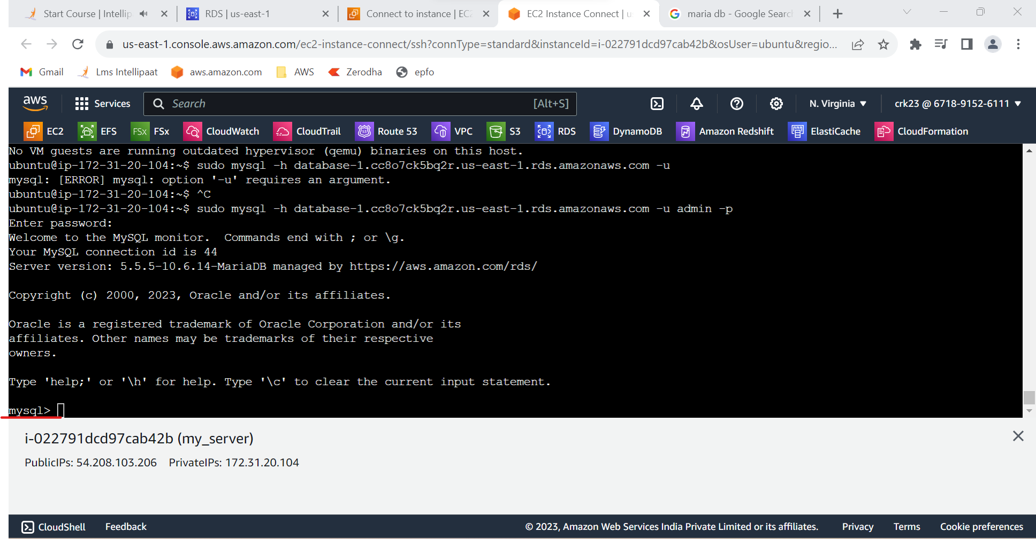

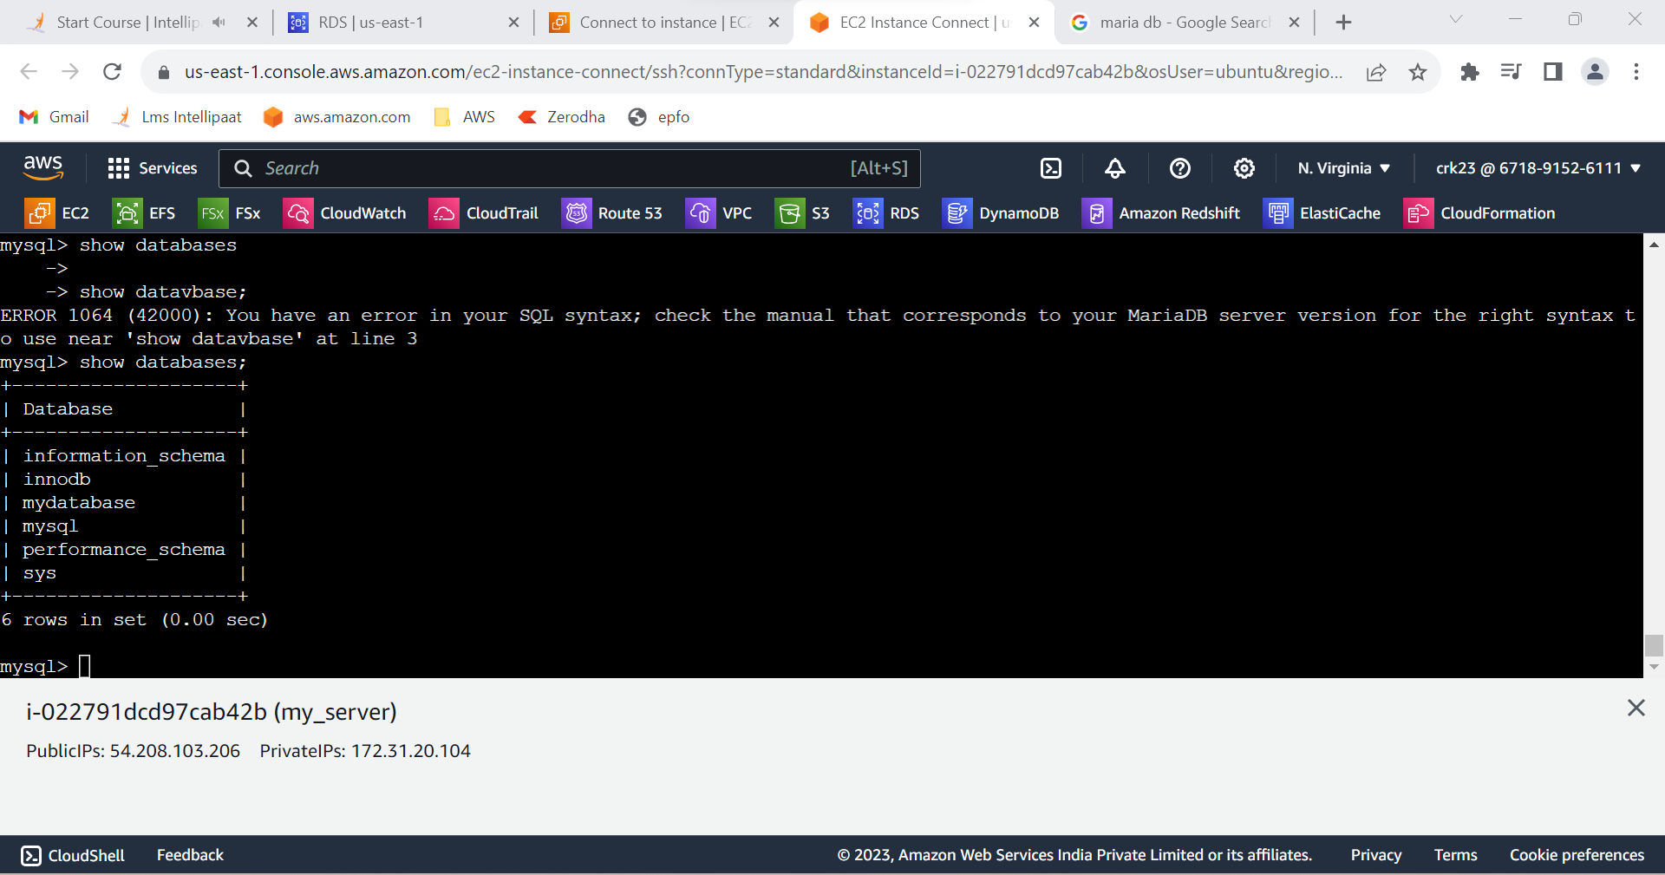

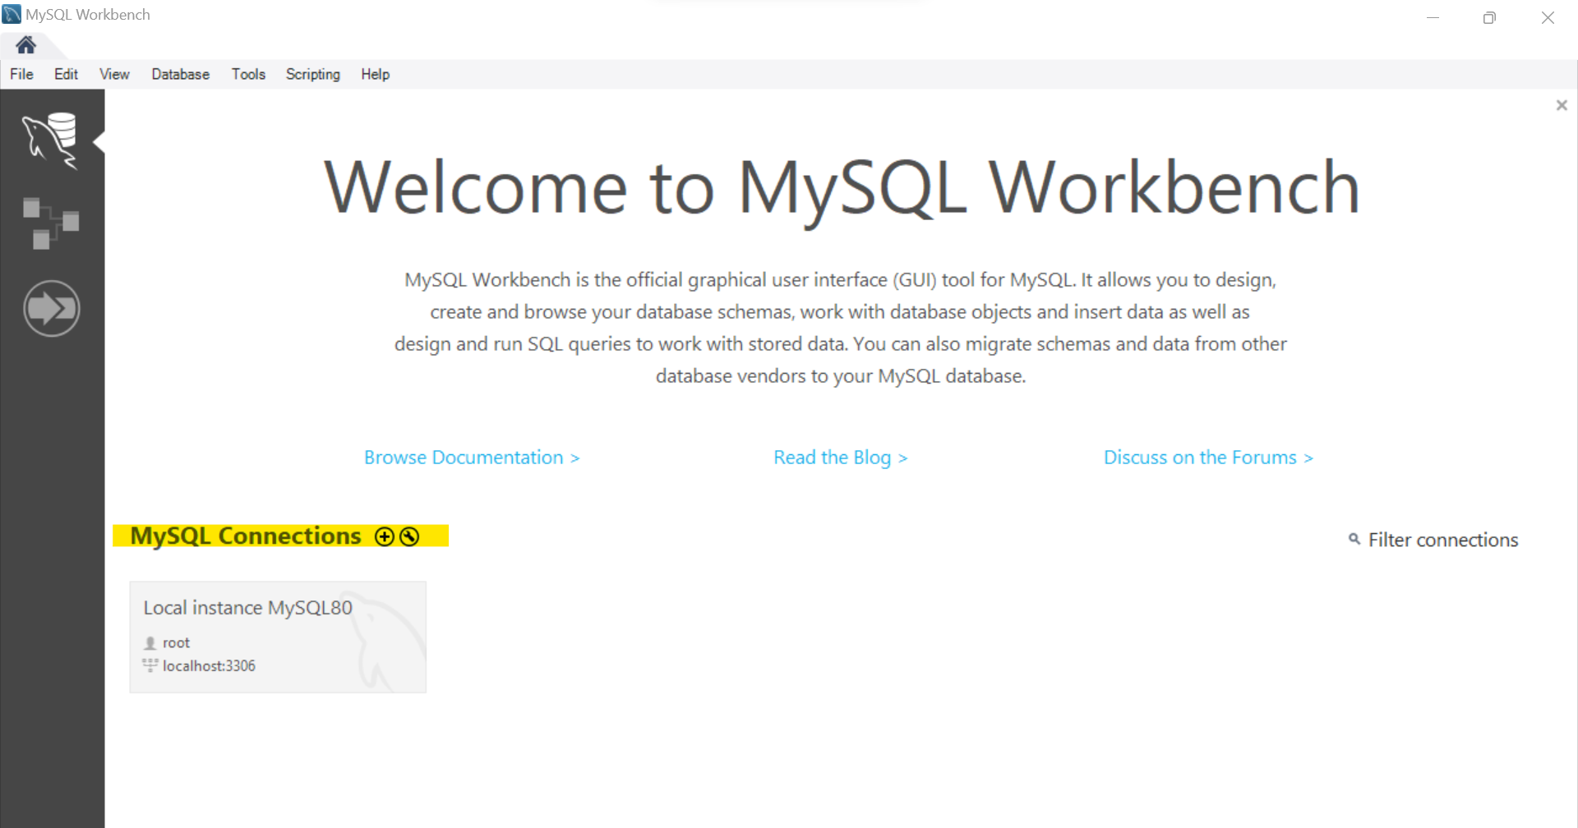

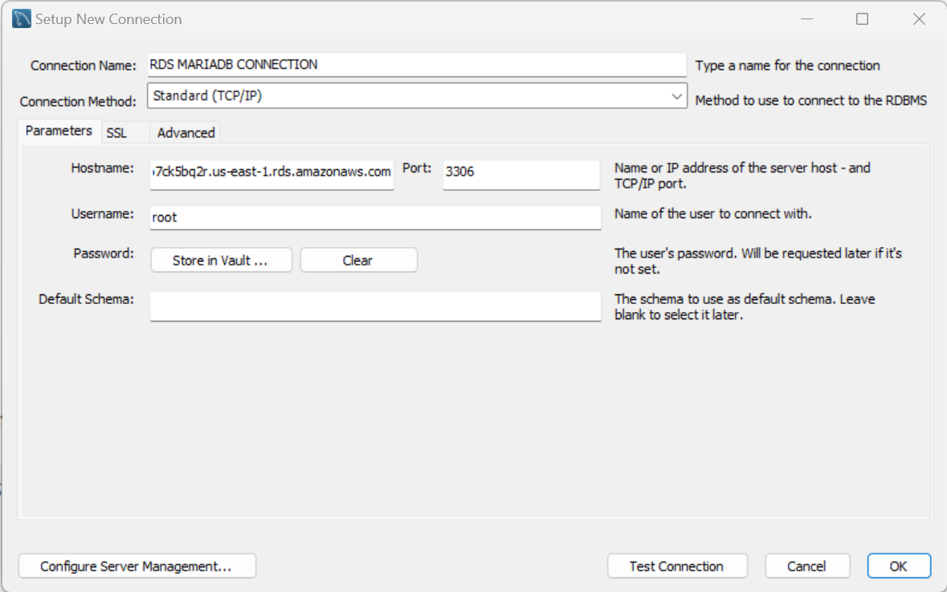

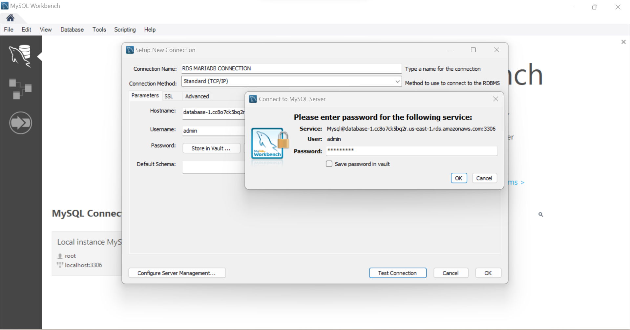

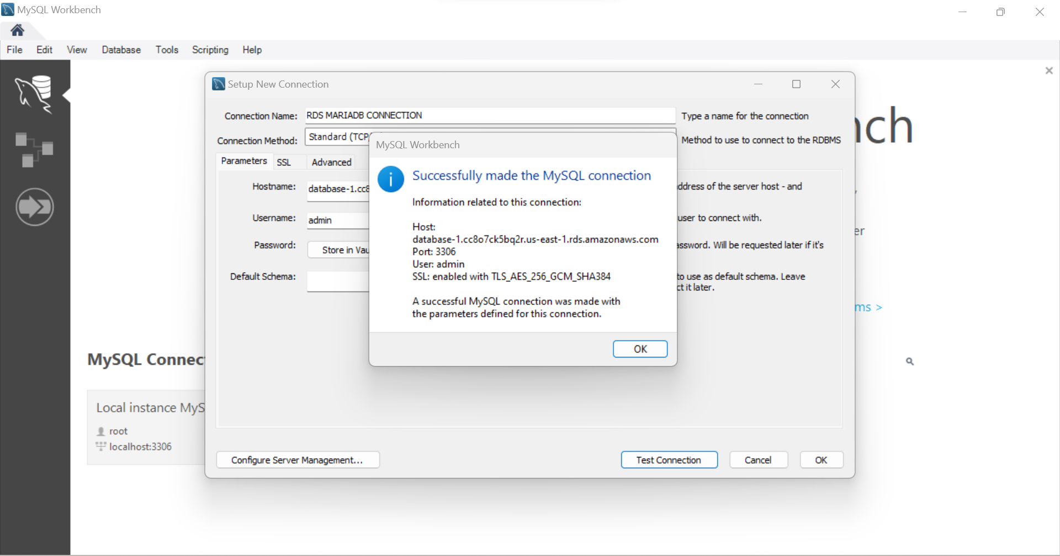

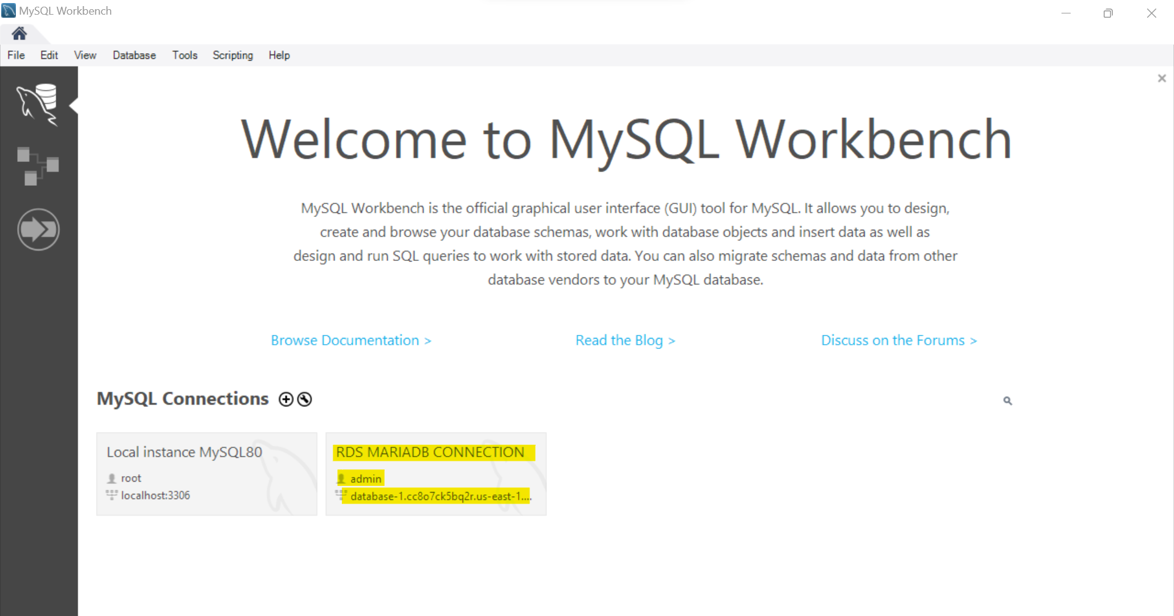

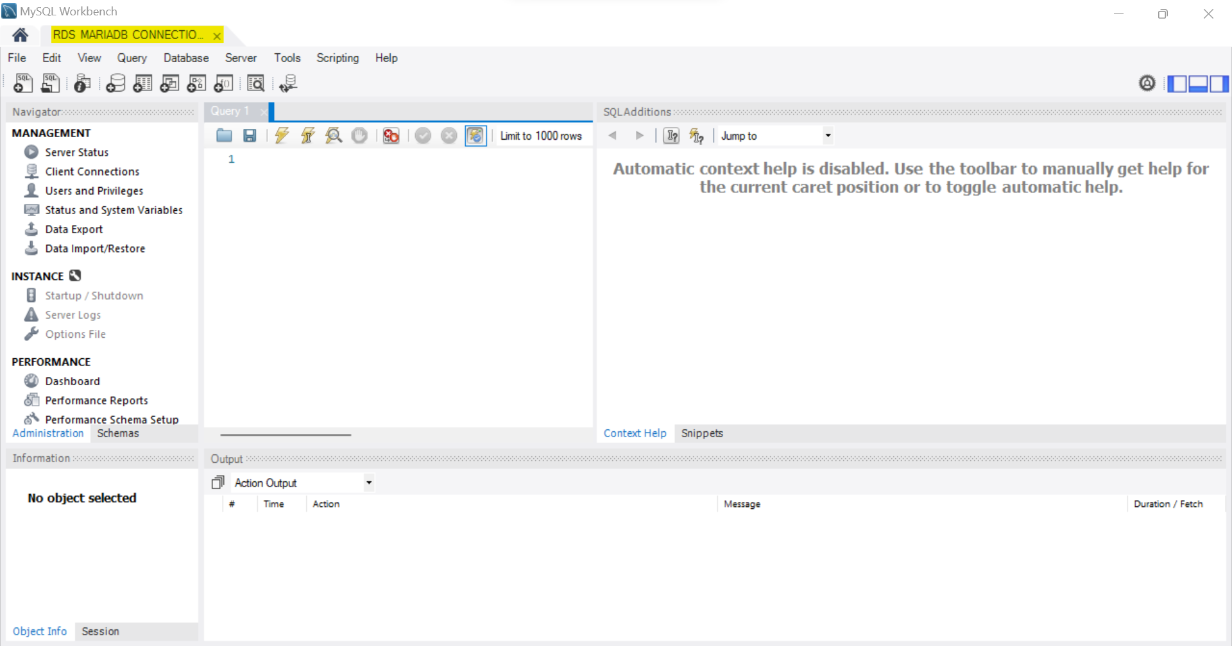

**OUTPUT :**

Created a MariaDB engine RDS Database and connected to the DB using linux based EC2 Instance and SQL client for Windows.